Application Architecture Diagram
Group 3: Cecilia Li, Fangyuan Lu, Isis Hernandez Moreno, Jiahui Han

- Statement of Purpose
Our group proposes to develop an application for cross-firm analysis of climate-related risk disclosures in sustainability reports of large global financial institutions, with a particular focus on how these risks are articulated under firms’ self-declared Sustainable Development Goal (SDG) commitments. The application targets climate risk and sustainability analysts within financial regulators, central banks, and multilateral institutions who are responsible for reviewing and comparing disclosure practices across systemically important banks.
The application will use publicly available sustainability and climate disclosures from G-SIB banks (e.g., JPMorgan, Citi, HSBC, UBS) as its primary text corpus. While these institutions often explicitly disclose which SDGs they align with, such disclosures are typically presented at a high level and are not systematically linked to detailed climate risk narratives in the underlying text. As a result, analysts must manually interpret long, unstructured documents to understand how climate-related risks, particularly transition risks and physical risks are framed within SDG-related disclosures and how these narratives compare across firms.
The core functionality of the application is a query-driven analytical workflow that enables users to submit structured questions over multiple disclosure documents. Given a user query, the system retrieves relevant disclosure excerpts and uses a large language model to (1) classify climate-related disclosures into standardized risk categories (e.g., transition versus physical risk), (2) associate these disclosures with a constrained set of climate-relevant SDGs based on firms’ self-declared alignment, and (3) produce evidence-grounded, cross-firm comparisons. Outputs will be structured (e.g., tables or JSON) and will include supporting excerpts from the source documents to ensure transparency and traceability.
The application is designed as an interactive analysis tool rather than a static report generator. Although the underlying disclosure corpus is relatively stable and updated periodically, analysts’ questions vary depending on regulatory focus, supervisory priorities, and emerging climate risks. Supporting dynamic, query-based analysis therefore adds substantial value relative to static summaries or manually prepared comparison reports.
A large language model is a necessary component of the application because the task requires semantic interpretation and structured reasoning over heterogeneous, unstructured disclosure text. Simple keyword search, rule-based systems, or static retrieval alone cannot reliably classify risk narratives, interpret SDG-related context, or generate comparable outputs across firms. The application will go beyond a basic LLM wrapper by incorporating document preprocessing, embedding-based retrieval, metadata-aware filtering, and constrained LLM reasoning to produce structured, evidence-linked results.

- Components & Data Flow
https://www.canva.com/design/DAHBa8a9Mxg/FVJIbOd14VQ08a5IRyYQzQ/edit

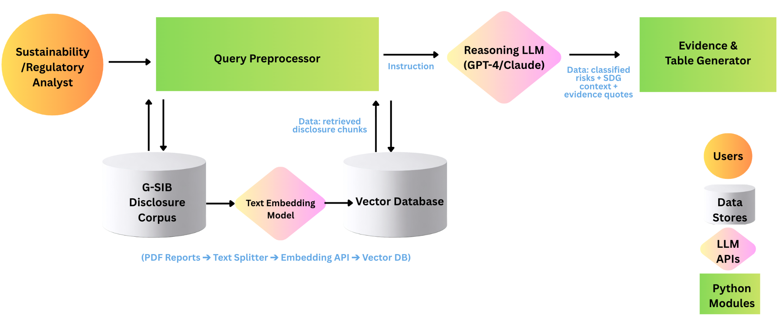
- A Sustainability Analyst submits a natural language query.
- The Query Preprocessor converts the request into a vector, which is used to retrieve the most relevant evidence from the Vector Database.
- The Reasoning LLM (GPT-4/Claude) analyzes the retrieved text to classify risks and map them to specific SDG goals.
- The Evidence & Table Generator compiles the AI’s analysis into a structured table with direct citations back to the original source documents.
REFERENCES:

Eberley, D. (2023, July 18). Climate-risk: Are financial regulators politically independent. FDIC.gov. https://www.fdic.gov/news/speeches/2023/spjul1823.html
Large language models: A Comprehensive Guide for Beginners. Data Science Dojo. (2024, April 18). https://datasciencedojo.com/blog/a-guide-to-large-language-models/#:~:text=It%20ensures%20that%20a%20large%20language%20model,LLMs%20are%20best%20suited%20for%20specific%20tasks.

Eberley, D. (2023, July 18). Climate-risk: Are financial regulators politically independent.
Large language models: A Comprehensive Guide for Beginners. Data Science Dojo. (2024, April 18).

